List slave codes & ways the slaves resisted them.
Slave Codes  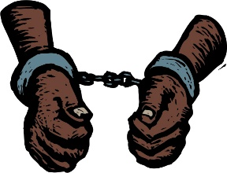 | Ways Slaves Resisted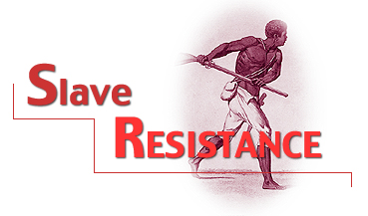
If you were a slave owner would you have been able to carry out the slave codes on a fellow human being? Why or why not?

If you were a slave would you have resisted the treatment allowed by the slave codes? If yes, how?

Would you have intervened if you saw another slave mistreated?

